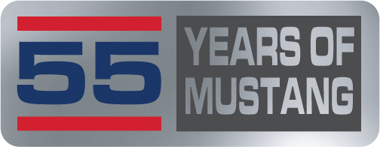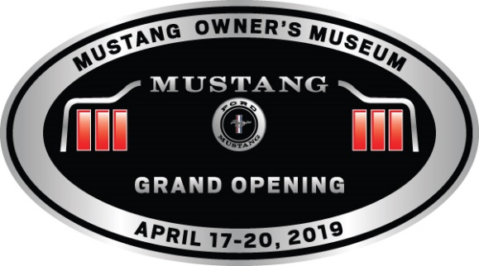

Volunteer Form
Location of Interest: Mustang Owner’s Museum Charlotte Motor Speedway
(Please circle the location)

Name(s) _____________________________________________
Phone __________________________ T-shirt size:___________
Email _______________________________________________

The Grand Opening of the Museum/55 Years of Mustang needs volunteers to help put on a great Mustang event. To accomplish this, we will need volunteers to help in the following areas, please mark the areas of interest:

At Mustang Owner’s Museum:

Parking ________ Information booth ________ Merchandise Store________

Transportation_________ Operations ___________

At 55 Years of Mustang (Charlotte Motor Speedway):

Merchandise Store_____ Operations ______ Event Registration ________

World Record Parade (Thursday) ___________ Goodie Bag ___________

Please mark the day(s) of interest to volunteer:

Tues. _____ Wed. _____ Thur. _____ Fri._____ Sat.______

Prefer AM Shift (8-12) ___________ PM Shift 12-5PM___________

All volunteers are asked to work a 4-5-hour shift on the day(s) of interest.
All volunteers will receive an event team t-shirt/$10 lunch voucher, for the 4-hr. shift.
Volunteer for a second 4-hour shift and receive either a second t-shirt or cap.
Volunteer for a third 4-hour shift and receive a travel mug.
Volunteer for a fourth 4-hour shift and receive a $25.00 gift certificate to the Museum Gift Shop.
Thank you for your interest and we look forward to seeing you at the Grand Opening of the Mustang Owner’s Museum and the 55 Years of the Mustang.

Volunteer Job Descriptions

Mustang Owner’s Museum-

Parking-Direct the Mustangs into designated parking areas in an orderly fashion, along with organizing the guests walking across the street to the Museum.

Information Booth-a tent facility with information to share with guests as to the where and how of the event…where is? How do I get to? Type of questions.

Merchandise store-assist guests looking for certain items and/or sizes, generally assisting the guests with any inquiries. Restocking areas low on product.

Transportation-assist guests needing transportation via golf carts/small van from the Mustang Owner’s Museum to the Carpenter Ford or Carpenter Mustang Museums.
The Carpenter locations are private collections only open by invitation or special events.

Operations-various areas needs from vendor relations to trash removal and fill in where more staff is needed, oversee vendor areas.

Charlotte Motor Speedway-

Vendor relations-assist vendors with any questions or needs, after the vendor has set up.

Goodie Bags-assist with all filling the event goodie bags, along with distribution to registered guests.

Event Registration-assist guests arriving to pick up their preregistered event packet, confirm the packet is correct. Work with each guest to insure their packet is correct.

Merchandise Store- assist guests looking for certain items and/or sizes, generally assisting the guests with any inquiries. Restocking areas low on product.

All volunteers will need to check in at the Charlotte Motor Speedway and at the Mustang Owner’s Museum to receive their team event t-shirt and at conclusion of the shift to receive their $10 lunch voucher. The CMS volunteer check in is at the Media Center. Check in for the Museum will be at the Volunteer Tent, located next to the Museum.
All volunteers must check in with the volunteer coordinator.
All volunteers will need to wear the Team Event t-shirt while being a volunteer.

Thank you for your interest and help making the 55 Years of Museum and Grand Opening of the Mustang Owner’s Museum a memorable event for everyone attending.

